

This looks good but for better visibility the size of the green block and the logo can be increased as much as possible.



**Call Us** instead of **Contact Support**. **Order Organic Essentials** instead of **Online Order**

**3.**

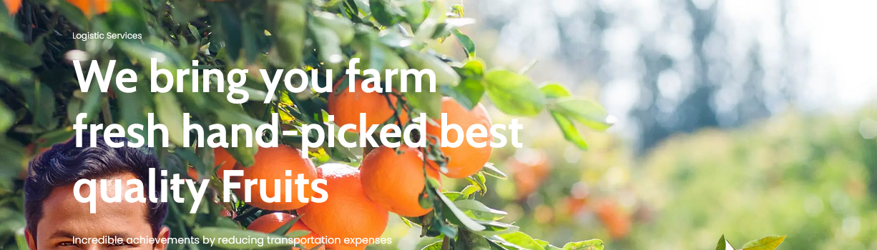

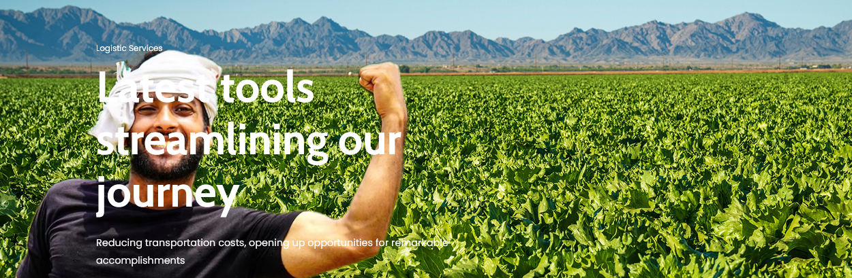

The text in the both the above pages can be moved to the right side for better visibility

4.

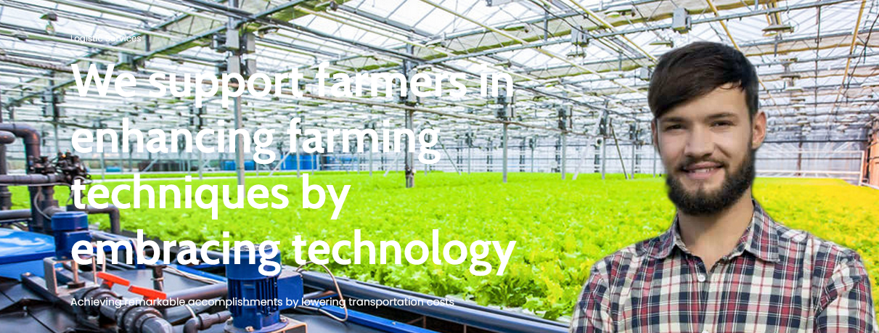

The font color in the text limits the visibility. A color that stands out may be used.

5.

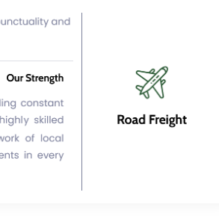

The Road Freight Logo/ Symbol to be corrected.

6.

No mention of Fresh Produce Logistics in the website.

Please add **Fresh Produce Logistics** under **Special Services**

An image symbol similar to the following image may be used

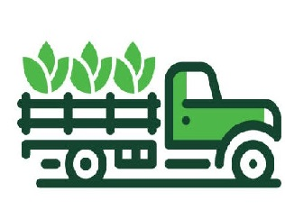

7.

In the Contact page, the updated address of the Spain office is:

NLN TAX & ACCOUNTING Compliance, S.L.

Paseo de la Castellana, 166,

Escalera 1 5th Dcha

28046 Madrid

Spain

8.

In the contact Us page, please remove the line **Find where we are** from all individual office addresses and use the line as a heading of the Contact Us

9.

Please remove the below details from the home page as the same is covered under the dedicated Know about us space

